**Frontend Assignment**

**Module – 2 (CSS and CSS3)**

**1). What are the benefits of using CSS?**

CSS handles the look and feel part of a web page. Using CSS, you can control the colour of the text, the style of fonts, the spacing between paragraph, how columns are sized and laid out, etc.

Advantage :-

Save time

Platform Independence

Easy maintenance

Easy for the user customize the online page

**2). What are the disadvantages of CSS?**

There exists a scarcity of security.

There might be cross-browser issues while using CSS.

Browser compatibility (some styles sheet are supported and some are not.)

**3). What is the difference between CSS2 and CSS3?**

|  |  |
| --- | --- |
| **CSS2** | **CSS3** |
| CSS does not support responsive design. | CSS3 is the latest version and supports the responsive design. |
| CSS is not divided into modules | CSS3 could split into modules. |
| CSS cannot produce 3D animation and transformation. | All kinds of transformations and animations are performed by using CSS3. |
| CSS provides unique colour schemes and standard colour. | CSS3 supports HSL RGBA, HSLA and the gradient colours. |

**4). Name a few CSS styles components.**

The components of CSS style are:

1. Selector : HTML element name, id name, class name.
2. Property : It’s like and attribute such as background colour, font-size, position, text-align, border, etc..
3. Values : Which defines property or values allocate for properties.

**5). What do you understand by CSS opacity?**

The **opacity** CSS property sets the opacity of an element. Opacity is the degree to which content behind an element is hidden, and is the opposite of transparency.

/* Global values */

opacity: inherit;

opacity: initial;

opacity: revert;

opacity: revert-layer;

opacity: unset;

**6). How can the background colour of an element be changed?**

E.g.

body

{

Background-colour: red:

}

**7). How can image repetition of the backup be controlled?**

To control the repetition of an image in the background, **use the background-repeat property.** You can use no-repeat value for the background-repeat property if you do not want to repeat an image, in this case, the image will display only once.

**8). What is the use of the background-position property?**

The background-position property **sets the starting position of a background image.** Tip: By default, a background-image is placed at the top-left corner of an element, and repeated both vertically and horizontally.

**9). Which property controls the image scroll in the background?**

The background-attachment property sets whether a background image scrolls with the rest of the page, or is fixed.

**10). Why should background and colour be used as separate properties?**

There are two reasons behind this:

1. It enhances the legibility of style sheets. The background property is a complex property in CSS, and if it is combined with colour, the complexity will further increase.
2. Colour is an inherited property while the background is not.

**11). How to center block elements using CSS1?**

With CSS the way center anything that’s block level element is **with the margin property.** One of the values of margin is auto and by setting auto on the left and right margin our block level element will center itself.

**12). How to maintain the CSS specifications?**

The specifications **defines how CSS properties should be implemented by browser vendors along with detailed algorithms, code samples and tabular information.** The specification also include: The syntax and data types of the language. Detailed explanation on CSS Selectors.

**13). What are the ways to integrate CSS as a web page?**

CSS can be added to HTML documents in 3 ways: **Inline – by using the style attribute inside HTML elements.** Internal – by using a <style> element in the <head> section. External – by using a <link> element to link to an external CSS file.

**14). What is embedded style sheets?**

**Embedded Stylesheet:** It allows you to define styles for particular HTML document as a whole in one place. This is done by embedding the **<style></style>** tags containing the CSS properties in the head of your document.

**15). What are the external style sheets?**

An external style sheet is **a separate CSS file that can be accessed by creating a link within the head section of the webpage.** Multiple webpages can use the same link to access the style sheet. The link to an external style sheet is placed within the head section of the page.

**16). What are the advantages and disadvantages of using external style sheets?**

**Advantages :-**

* With the help of external style sheets, the styles of numerous documents can be organized from one single file.
* In external style sheets, classes can be made for use on numerous HTML element types in many forms of the site.
* In complex contexts, Methods like selector and grouping can be implemented to apply styles.

**Disadvantages :-**

* Extra download is essential to import style information for each file.
* The execution of the file may be deferred till the external style sheet is loaded.
* While implementing style sheets, we need to test web pages with multiple browsers in order to check compatibility issues.

**17). What is the meaning of the CSS selector?**

CSS selectors are used to “find” (or select) the HTML elements you want to style.

**Type :-**

* Element selector
* Id selector
* Class selector
* Universal selector
* Multivalued selector ( group selector )

**18). What are the media types allowed by CSS?**

**Two ways to specify media dependencies for style sheets :-**

* Specify the target medium from a style sheet with the @media or @import at- rules.
* Specify the target medium within the document language.

<style type=”text/css”>

<!- -

@media print

{

body { font-size: 10px }

}

@media screen

{

body { font-size: 12px }

}

@media screen,print

{

body { line-height: 1.2 }

}

-- !>

</style>

**19). What is the rule set?**

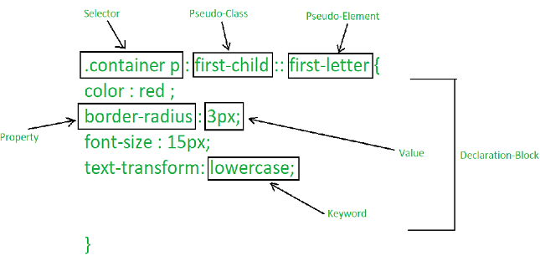

A CSS ruleset is **various affirmations to various pieces or elements of the document.**

**20). Create Layout**

https://github.com/jayminnai/Practicals.git